It is important for you to rate the items that make you feel highly anxious – when you score them, it moves the feelings out of the RIGHT side of your brain (the emotional side) and moves them to the LEFT side of your brain (the logical side). When something changes from our emotional brain to our logical brain – we can then create solutions!

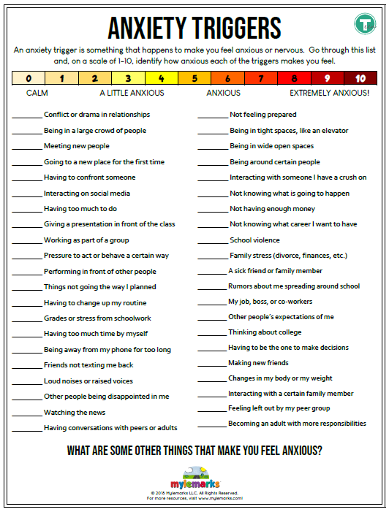

Strategies for Managing Stress and Anxiety

Centering Techniques
To help calm ourselves, it can be helpful to use techniques designed to focus and attune to something beyond our anxious thoughts. We can do this by…..

Meditation – find one that fits your personality on Youtube – there are so many!
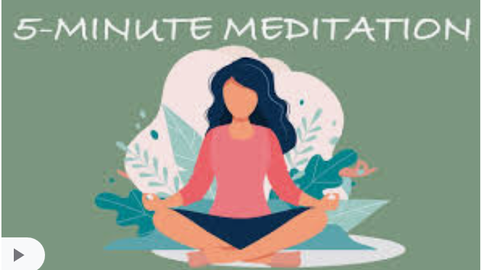

Breathing – here is one breathing strategy called Box Breathing – give it a try!
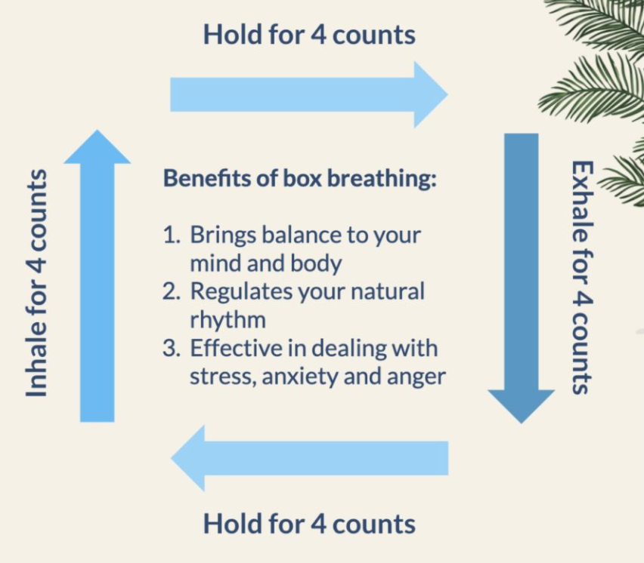

Visualization – pick your favourite place to be and go there in your mind. For example, if you like going to the beach ….

Step 1: Visualize yourself lying on a white sandy beach, complete with clear blue skies and gently lapping waves.
Step 2: Imagine your body sinking into the chair and feel the warmth of the sand on your feet.
Step 3: Let go of any tension, soften your eyes and continue to breathe in time with the rolling waves of the water.

Grounding – to help keep you “present” and in the current moment, this is a fun exercise to try…. you can practice on your friends

